Project Proposal

**Project Description**

Name: Edge

Description: Inspired by the character and the idea of creating geometric illusion in Monument Valley; having a random-maze generator that can create maze that contains illusory geometric shapes; having an adjustment tool for the user to control the difficulty of the maze

**Competitive Analysis**

Similar projects that are intended to reproduce Monument Valley appear as past-year 112 term project. They’re featured by customization of maze. My project will generate random maze for the user to solve and have more attractive models. (And if it’s possible, I can develop the multiplayer mode, analogous to Monument Valley 2 in which two characters get involved)

**Structural Plan**

One file in pure python that contains the core algorithm of how to generate a random Monument Valley maze

One file using Panda 3D to display the board that actually interacts with the user

One file that stores all functions in tracking the character’s position, moving the character around, rotating pieces, and all earlier built impossible geometric shape models and blocks of path

**Algorithmic Plan**

This algorithm will scale the fundamental blocks randomly and connect them according to a dictionary that stores all the boolean information whether two types of blocks can be connected and another dictionary that records their relative arrangement (ex. two vertical blocks cannot be parallelly connected). The maze will be constructed from the impossible geometric shape (since it’s fixed), so for example, for an impossible triangle, there’ll be two paths connected to it before moving the piece around and two paths connected to it after the rotation.

The difficulty level of the game is controlled by the total number of pieces involved in generating the maze and the number of triggers and impossible shapes. Mazes that contain multiple geometric illusion can be a somehow composition of two fundamental maze (one that only contains on trigger or shape)- also see a possibility here to employ recursion.

**Timeline Plan**

For TP1 I’ve already ‘hard-coded’ a simple solvable version of maze – pass the display using Panda 3D by figuring out methods needed during user interaction

For TP2 I’ll focus on coming up the core algorithm, the random maze generator (during Thanksgiving break)

For TP3 I’ll focus on the rest part, maybe improve some feature of user experience and smooth transition, elaborate on models etc.

**Version Control Plan**

Daily backup in Github and Google Drive

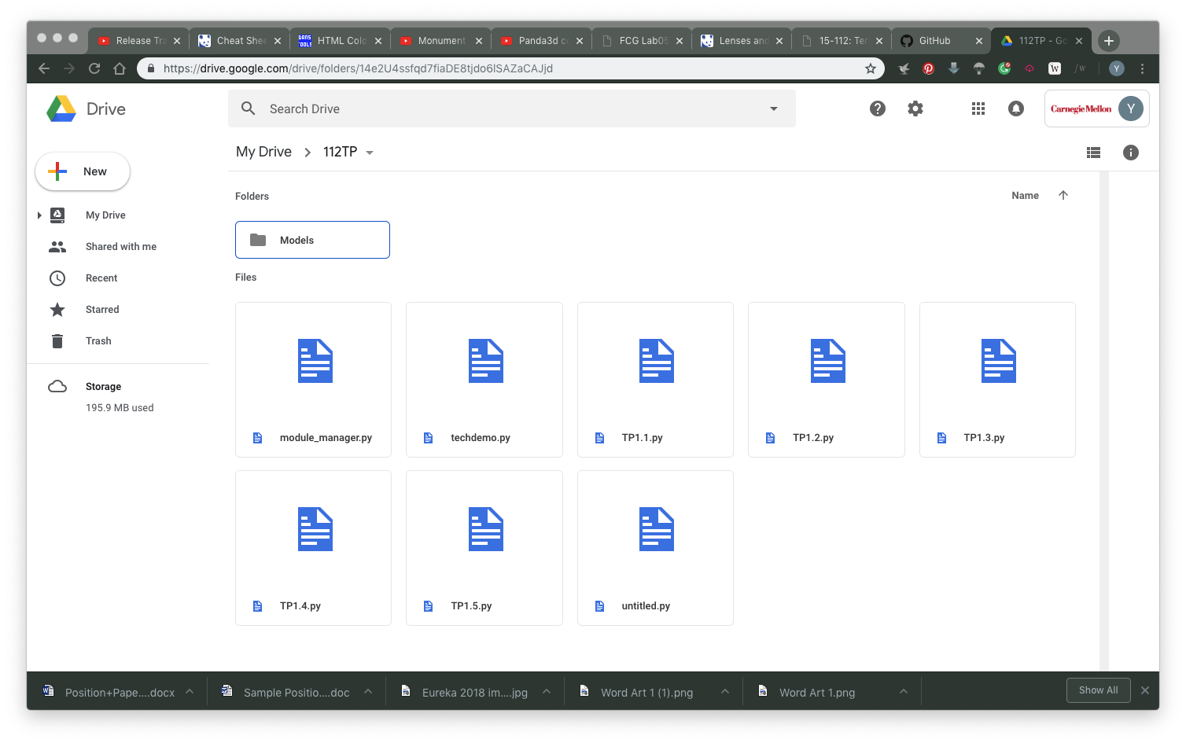

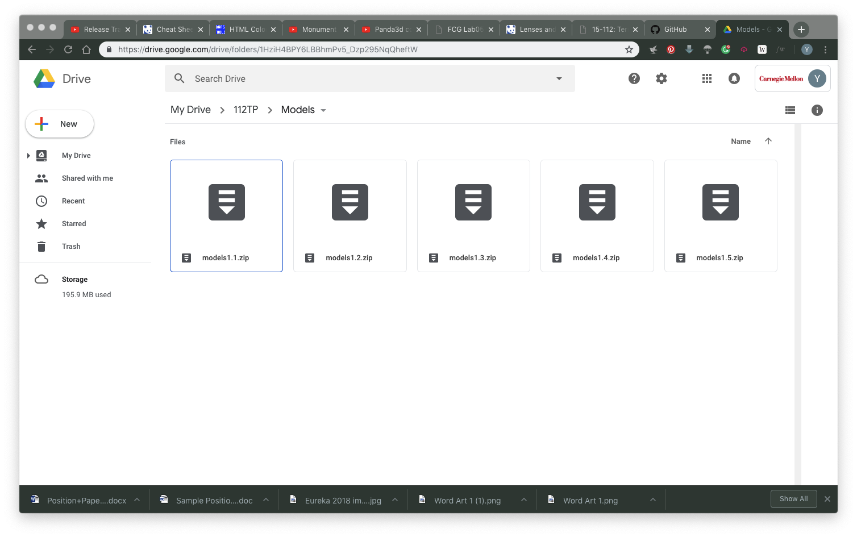

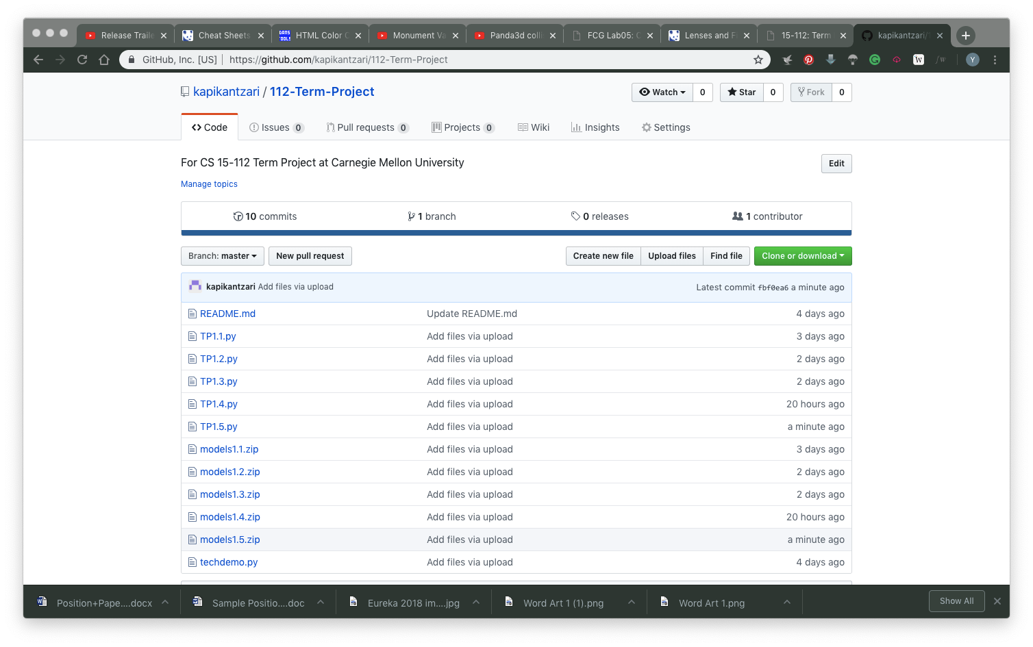

**Module List**

Panda 3D (passed Techdemo); Socket (optional, haven’t passed Techdemo)